
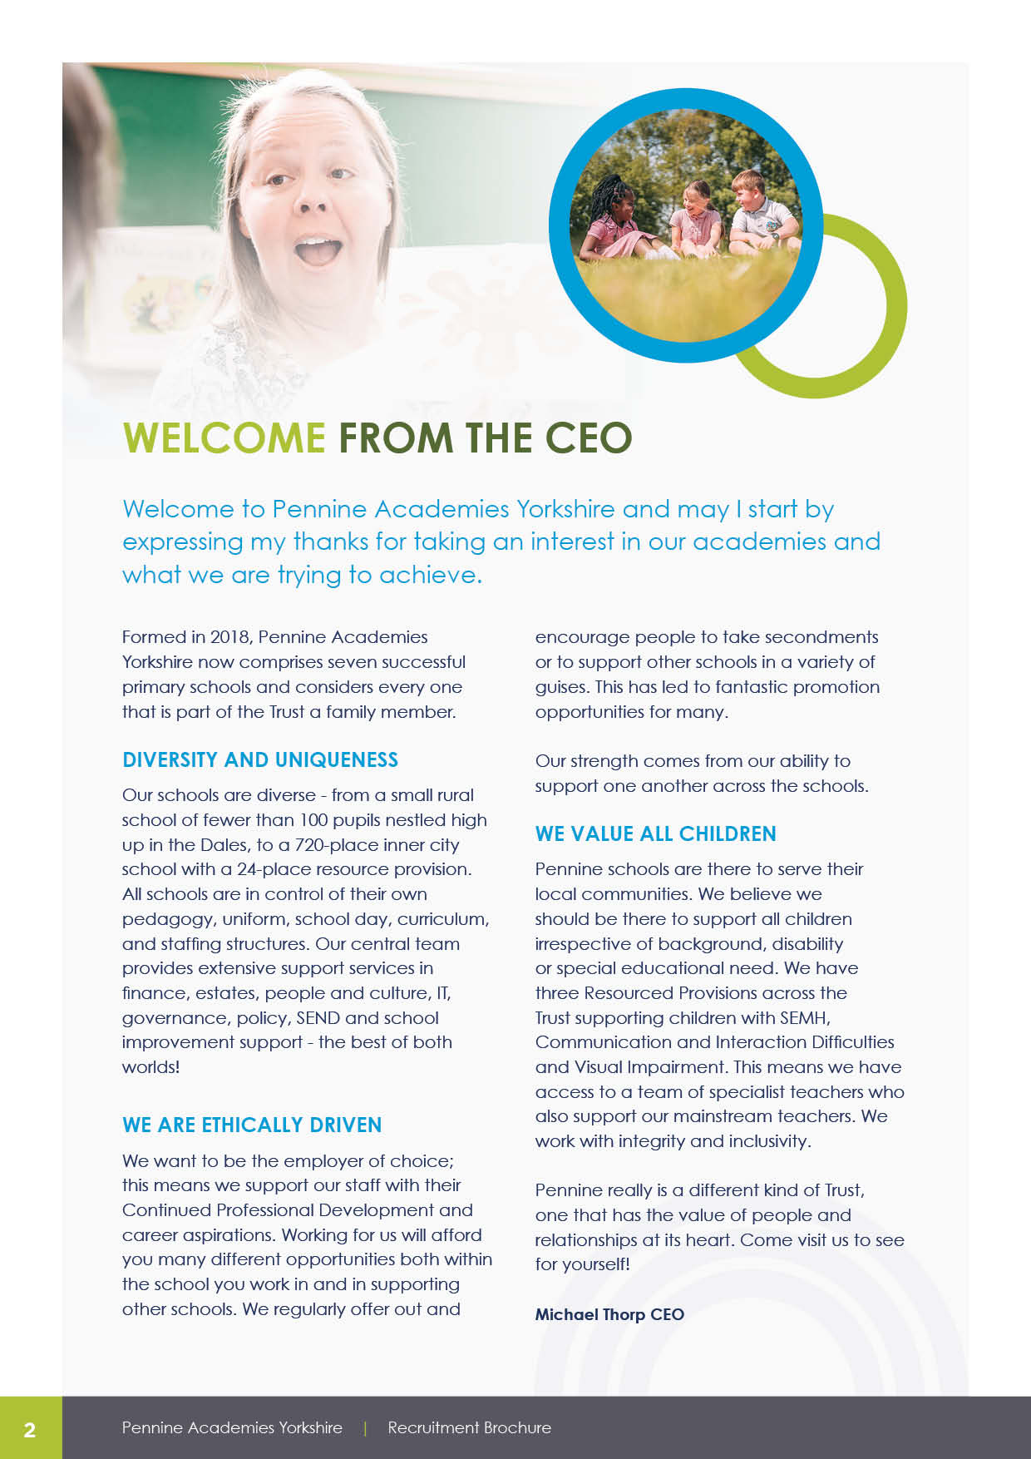

WELCOME
FROM THE HEADTEACHER

Dear Candidate

Let us tell you more about our amazing school! We are a thriving, energetic and vibrant three-form entry primary school, situated in the Fairweather Green area of Bradford. Our school stretches across three buildings, a mixture of traditional and modern. We form part of Pennine Academies Yorkshire Multi Academy Trust, a growing Trust consisting of 6 schools. Here at Crossley Hall, our team of dedicated teachers bring our curriculum to life, in line with our school values of aspiration, inclusion and happiness.
To us these values mean:
- Aspiration – being full of hope for something better and working hard to make it happen.
- Inclusion – we value diversity; everyone feels safe and has a sense of belonging.
- Happiness – being curious, being respectful and having confidence = happiness
Reading, writing and maths are taught using evidence-based principles such as ‘White Rose Maths’ and Read Write Inc. Our approach to teaching the wider curriculum uses our ‘Bradford roots’ as the underpinning starting point. We complement our classroom-based learning with lots of additional experiences to promote both academic achievement and wellbeing. Every year, each year group has the opportunity to visit three or more places to enhance their learning experiences. We believe all our children are included in all external visits so that they can experience the world beyond Bradford and aspire to be whatever they want to be.
The behaviour of our pupils is good because we build positive relationships based on mutual respect- everyone is expected to be kind, polite and hard working. As a school, we actively promote diversity, tolerance and respect for people of all faiths and backgrounds, and there is a real sense of harmony and dedication from staff and pupils alike. Our pupils love coming to school! We enjoy celebrating each other’s successes in our weekly ‘Celebration Assembly’ which parents enjoy attending too.
Mental Health and Wellbeing are central to what we do here at Crossley Hall Primary School. Members of our SLT are trained Youth Mental Health First Aiders. We also actively support the wellbeing of our staff; two members of our staff are trained as Mental Health First Aiders and can provide support/advice to our staff.
Not only do we have enthusiastic, well-behaved pupils, we also have a talented team of motivated and dedicated professionals, who, along with the leadership team, are united in the strong sense of ambition for the school. Our team of Support Staff are confident and highly skilled. Our inclusive ethos resonates throughout the school, and we are proud to cater fully for our children with additional needs. Our Resourced Provision for children with Communication and Interaction Needs (including Autism) work closely and collaboratively with the rest of the school.
Finally, please be rest assured that we take the Professional Development of all staff seriously. We listen to our staff's needs and develop bespoke CPD opportunities across the year. We strongly advise you to come and visit and find out more!
Eleanor Monnery
Headteacher, Crossley Hall Primary School

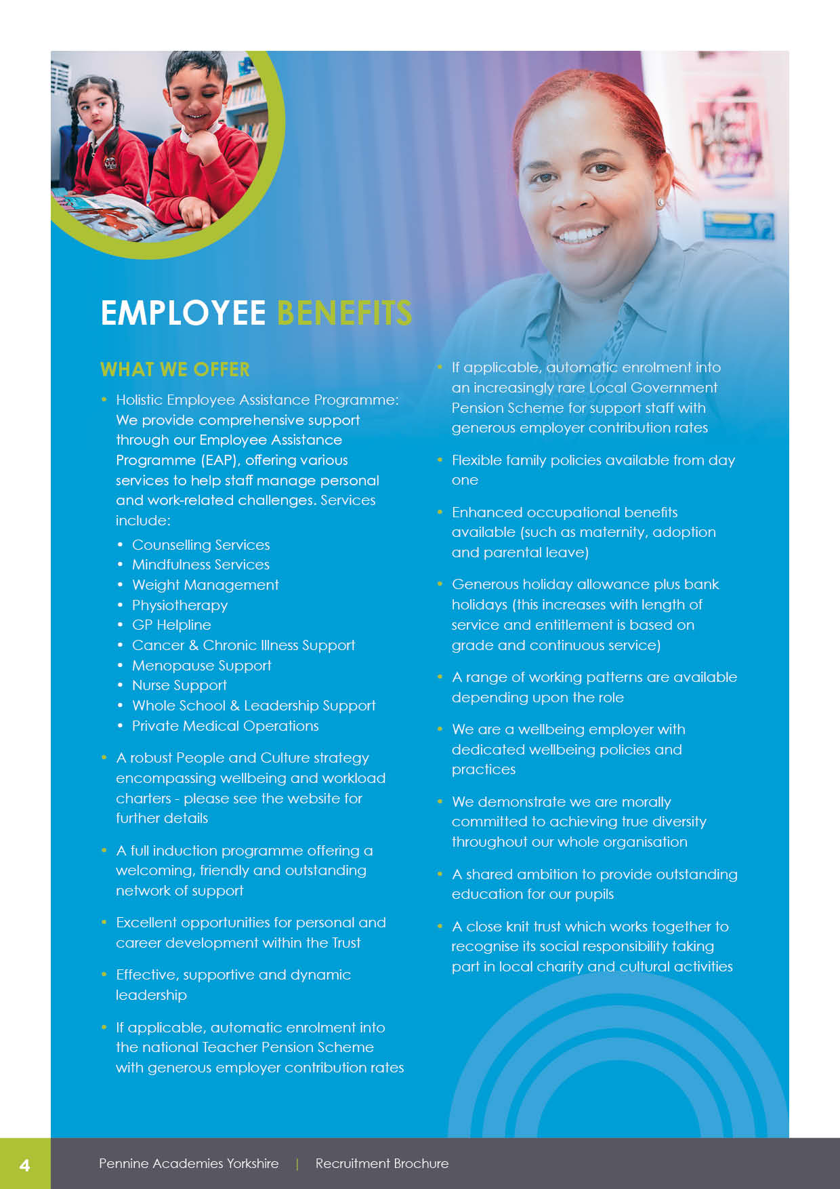
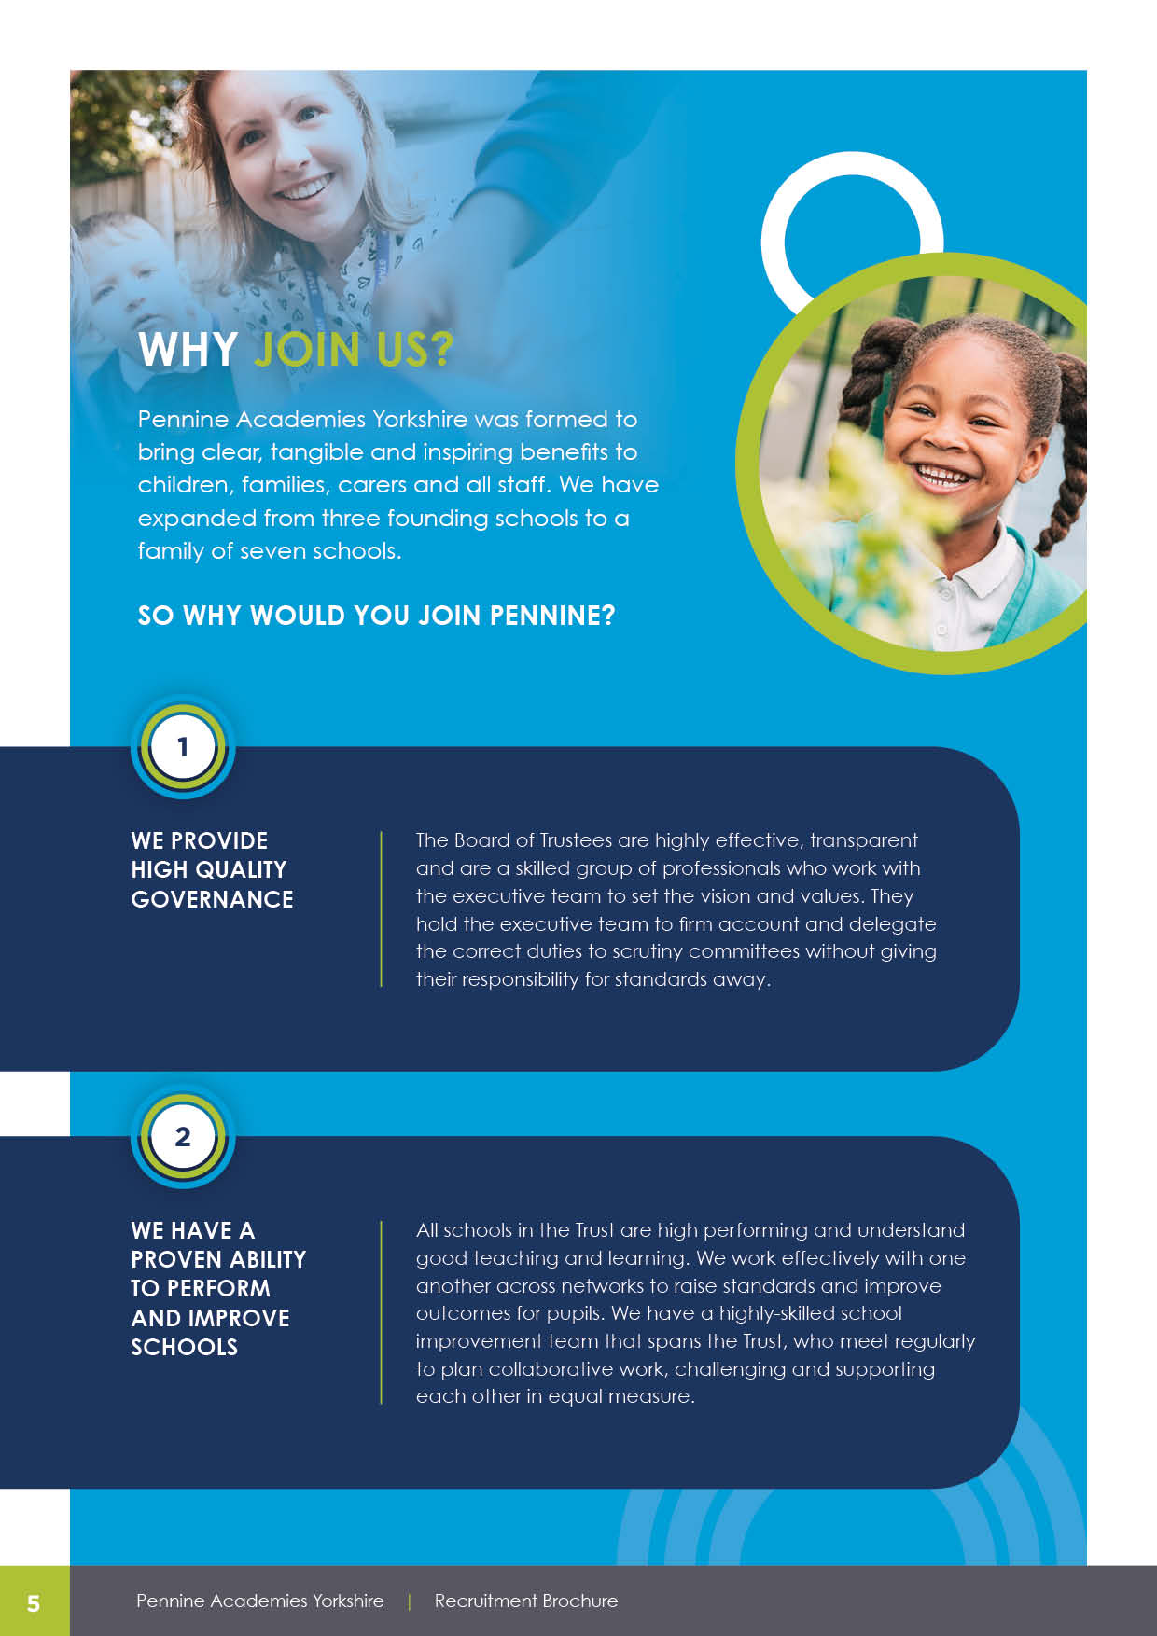
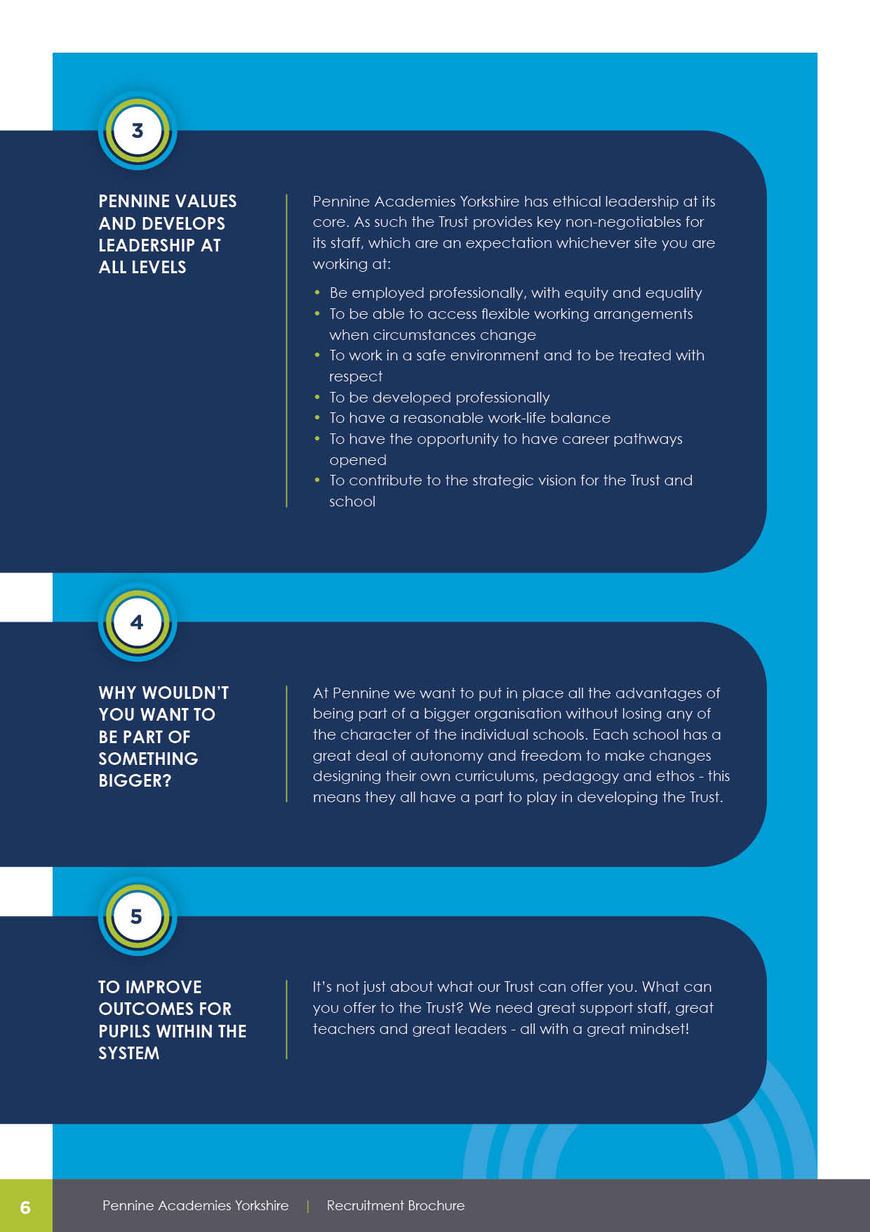

MPS – UPS plus SEN point. Full Time. Permanent.

Are you committed to improving pupil outcomes? Hardworking with a sense of humour? We are looking for a Specialist Teacher to join our driven and passionate team. You will need to be hardworking, resilient and with the highest of expectations of our pupils as well as the ability to work as part of a flexible and happy team.

As a Resourced Provision Teacher at Crossley Hall Primary School, we will offer you:

✔ Tailored CPD and opportunities to support career progression
✔ Enthusiastic children who are keen to learn
✔ A positive and thriving working environment
✔ A supportive leadership team

Pennine Academies Yorkshire Trust is committed to safeguarding and promoting the welfare of young people and we expect all staff to share this commitment. All posts are subject to the safer recruitment process including an enhanced Disclosure and Barring Service Check. The post includes engaging in regulated activity with children and young people. It is an offence to apply for the role if the applicant is barred from engaging in regulated activity relevant to children
Please see our website https://crossleyhallprimary.co.uk/ to view our Safeguarding Policy.
Shortlisted applicants will need to provide evidence of their eligibility to work in the UK.
Visits to the school are warmly welcomed by arrangement. Please contact the Operations Manager to arrange an appointment or to ask for further information on 07741 164878 or e.jarockyj@chps.paymat.org

” Staff have equally high expectations of pupils’ learning. This includes the youngest children. Pupils in all key stages achieve well.”

What Ofsted say
(May 2023)
RESOURCED PROVISION TEACHER

ASAP
CLOSING DATE:
Monday 23rd March 2026 at 9am
INTERVIEWS:
Friday 27th March 2026
Crossley Hall Primary School | T 01274 488703
Headteacher: Eleanor Monnery

JOB TITLE/POST: | RESOURCED PROVISION TEACHER
SALARY: | MAIN PAY SCALE - UPPER PAY SCALE + SEN POINT
RESPONSIBLE TO: | HEADTEACHER
DATE: | ASAP

GENERIC INTRODUCTION:
The following information is furnished to assist staff joining the School to understand and appreciate the work content of their post and the role they are to play in the organisation. The following points should be noted:

- Whilst every endeavour has been made to outline the main duties and responsibilities of the post, a document such as this does not permit every item to be specified in detail. Broad headings, therefore, may have been used below, in which case all the usual associated routines are naturally included in the job profile.
- Employees should not refuse to undertake work, which is not specified on this form, but they should record any additional duties they are required to perform and these will be taken into account when the post is reviewed.
- Pennine Academies Yorkshire is an Equal Opportunities Employer and requires its employees to comply with all current equality policies in terms of equal opportunity for employment.
- Pennine Academies Yorkshire is committed, where possible, to making any necessary reasonable adjustments to the job role and the working environment that would enable access to employment opportunities for disabled job applicants or continued employment for any employee who develops a disabling condition.

- 
KNOWLEDGE AND SKILLS:
(See Personnel Specification)

RANGE OF DUTIES INCLUDE:
- Plan and prepare in order to teach, according to educational needs, children assigned to them.
- Assess record and report on the development, (intellectual, social, emotional and behavioural), progress and attainment of children.
- To provide a stimulating and challenging learning environment for children.
- Promote the general progress and wellbeing of all individual children within school.
- Observing pupils in the classroom, to coach and train colleagues
- Keeping all paperwork including records and policies, up to date and actioned, as appropriate
- Meet with parents to support SEND and pupils’ healthcare
- To monitor the quality of SEND support delivered both by teachers and support staff
- To support and maintain the SEND register of pupils
- To ensure that awareness of SEND issues is maintained across all of the teaching staff
- Participate in performance management.
- Participate in professional development.
- To have knowledge of and implement all school policies.
- Maintain good order and discipline and safeguard children’s health and safety when concerned with both in and out of school activities.
- Participate in all team-planning meetings where appropriate.
- Participate in national and school-based assessment procedures.
- Ensure care and replacement of both classroom and central equipment, labelled to the levels of the National Curriculum.
- To encourage parental interest and involvement within school guidelines.
- To abide by the internet acceptable use policy.

KNOWLEDGE, SKILLS AND APTITUDES:
(See Personnel Specification)
SUBJECT SPECIFIC KNOWLEDGE AND SKILLS:
- To monitor and evaluate the planning and delivery of a subject curriculum area throughout school, with high expectations to raise standards and actively looking for ways to extend learning and provide enriching experiences and be responsible to the Headteacher
- To be responsible for monitoring standards in the curriculum area across school taking appropriate action where necessary, particularly tackling underperformance in pupils for their subject area and identifying and addressing barriers to achievement of all pupils
- To model the school’s values and ethos and be responsible for writing an action plan detailing the development of their subject area and monitors and evaluates closely the specific targets set for the subject area in line with the school priorities


TEACHING & LEARNING:
- Adhere to all the Teacher’s Standard outlined in the current STPCD.
- Make a significant contribution to the development of the teaching and learning policy and practice across our Resourced Provision.
- Under the direction of the Headteacher and working alongside the AHT for Inclusion, to be responsible for the teaching and learning within the specialist SEND class.
- Be supportive of mainstream class teachers in building capacity and confidence to include our SEND pupils successfully into the mainstream classrooms
- Develop and maintain good communication with parents and carers and all relevant external agencies.
- Advise mainstream staff regarding effective curriculum and assessment procedures to meet need
- Raise standards of achievement so that our SEND pupils achieve the best possible attainment and progress given their relative starting points.
- Advice and model for mainstream staff how to secure high standards of teaching and learning for our children within the SEND class.
- Be responsible for the quality of resources within the class
- Work alongside SLT to track the progress of our pupils within the SEND class, to analyse data and report progress and identify effective interventions where necessary.
- With support of SENCo play a key role in the annual reviews of children with EHCPs .
- Develop a strong partnership based on trust with the parents to support their child’s ongoing development throughout their primary school journey.
- With parents, ensure all transitions are well planned and implemented effectively.
- Provide an appropriate curriculum, which is accessible for all the SEND class pupils including educational visits and other school activities.
- Provide a personalised curriculum for all pupils of the Resourced Provision with particular focus on their social, communication and interaction needs.
- Support staff to recognise that they are accountable for the progress and attainment of the children within the Resourced Provision.
- To monitor and evaluate the planning and delivery of curriculum areas throughout school and be responsible to the Headteacher.
- To be responsible for monitoring standards in the curriculum area across school taking appropriate action where necessary.
- To be responsible for writing an action plan detailing the development of the above-names subject over this academic year, to be monitored and evaluated by the curriculum manager.
- The be responsible for ordering resources for the above-names subject working within the agreed action plan and a specified budget delegated by the headteacher.

RESPONSIBILITIES

EFFORT DEMANDS:
- Will contribute to the overall ethos/work/aims of the school.
- Will appreciate and support the role of other professionals.
- Be vigilant and sensitive to any child protection/safeguarding concerns that arise, reporting any concerns to the Designated Safeguarding Leads in line with school policy and procedure.
- Will deal with any issues, immediate problems or emergencies that arise in line with school policies and procedures liaising with colleagues where necessary e.g. dealing with a sick, injured or distressed child.


HEALTH, SAFETY AND DISCIPLINE:
- To ensure a safe, secure and healthy environment for pupils
- To manage pupil behaviour in the classroom and on school premises, and apply appropriate and effective measures in cases of misbehaviour
- To actively encourage good practice with regard to punctuality, behaviour, standards of work and independent learning.

PROFESSIONAL KNOWLEDGE & DEVELOPMENT:
- To maintain a thorough and up to date knowledge and understanding of the current SEND Code of Practice and of the school’s curriculum and policies
- To participate in INSET provided by the School
- To ensure that the School’s Health and Safety Policy is followed
- Support annual reviews and attend when necessary

COMMUNICATION:
- To write reports for parents on the pupils receiving specific teaching
- To liaise with parents and carers concerning pupil progress and concerns, and concerning updates to the MSPs, and to be proactive in communication about these issues

WORKING WITH COLLEAGUES AND OTHER RELEVANT PROFESSIONALS:
- To liaise with other professionals, such as learning mentors, careers advisers, educational psychologists, education welfare officers etc.

ENVIRONMENTAL DEMANDS/WORKING CONDITIONS:
- Will have long periods of sitting or standing.
- Available to work during school hours during term time and a willingness to be flexible as may be required to attend staff meetings/training sessions outside of usual hours.
- Will have contact with members of the public/other professionals e.g., teaching staff, governors, parents/carers, community groups, local education authority, external providers etc.
- The post holder may occasionally be subjected to antisocial behaviour from members of the public/parents/site users.
- This post may include a degree of manual lifting and handling. You are expected to be aware of health and safety policies and procedures and frequently assess your ability to carry out the lifting tasks required of you.
- Report all concerns to an appropriate person.


SPECIAL CONDITIONS OF SERVICE:
- No contra-indications in personal background or criminal record indicating unsuitability to work with children/young people/vulnerable clients/finance (An enhanced DBS check is required).

OTHER CONSIDERATIONS
- To be aware of and comply with policies and procedures relating to child protection; being vigilant for signs that children may be being abused and to report any such suspicions to the school’s nominated Child Protection Co-ordinator or the Headteacher.
- To act in accordance with the Data Protection Act and maintain confidentiality at all times e.g., access to staff/student/parent and carers files.
- Accept and commit to the principles underlying the Schools Equal Rights policies and practices.
- Be able to perform all duties and tasks with reasonable adjustment, where appropriate, in accordance with the Equality Act.
- Must be legally entitled to work in the UK.


ESSENTIAL CRITERIA | - A degree or equivalent higher degree qualification, postgraduate courses  - QTS status  - Experience of teaching children with communications and interaction difficulties  - Experience of planning for children with a wide range of need.  - Experience of delegating to a wide support team  - Proven ability to communicate with parents and build strong trusting relationships.
 | JOB SPECIFIC EVIDENCE:
EXPERIENCE | - Experience as an excellent primary practitioner  - Experience of pastoral care with both pupils and staff  - Experience of assessment procedures including B squared or similar  - Awareness of child development from ages 2-11  - An understanding of the issues relating to pupils who have additional learning needs and special educational needs  - An understanding of the needs of a multicultural society  - Experience of working with a team delivering staff development initiatives  - Evidence in supporting children to meet their EHCP targets  - Experience of meeting sensory needs  - Experience of using Makaton/ BSL/ visual prompts  - Experience working alongside external professionals and implement actions.
QUALIFICATIONS / TRAINING | - Evidence of Continuing Professional Development  - Up to date knowledge and understanding of what constitutes effective teaching and learning  - Knowledge and understanding of special needs education  - Effective knowledge of both statutory and non-statutory content of current educational practice  - Willingness to participate in development and training opportunities


KNOWLEDGE/SKILLS: | - Ability to relate well to pupils and adults  - Work constructively as part of a team  - Ability to remain calm under pressure  - Demonstrate good co-operative, interpersonal and effective listening skills  - Demonstrate a commitment to working with children of the relevant age  - Flexibility and willingness to accept change  - Approachable, courteous and able to present a positive image of the school  - Maintain confidentiality in matters relating to the school, its pupils, parents and carers.  - Good Maths and English skills  - Ability to use relevant technology (after training, if required)  - Adequate computer skills  - Ability to understand classroom roles and responsibilities and your own position within these  - Ability to motivate commitment among all staff groups and to lead staff meetings
PERSONAL CIRCUMSTANCES: | - Must be legally entitled to work in the UK (Asylum and Immigration Act 1996)  - Will not require holiday leave during term time  - No contra-indications in personal background or criminal record indicating unsuitability to work with children/young people/vulnerable clients/finance (DBS check required)  - Must be able to perform all duties and tasks with reasonable adjustment, where appropriate, in accordance with the Equality Act 2012.  - Ability to cope with requirements of the post, which may include working with pupils who have emotional and behavioural difficulties or physical difficulties.  - For posts working with pupils who have physical difficulties, it may be an unavoidable core component of the job for the post holder to be capable of lifting and carrying pupils, within school policies and practices and training.


Pennine Academies Yorkshire
Farnham Primary School,
Stratford Road
Bradford
BD7 3HU

T 01274 271164
E contactus@paymat.org

WWW.PAYMAT.ORG

